DME Internal Latch Lock – DKL
CAM Finger Removal & Installation

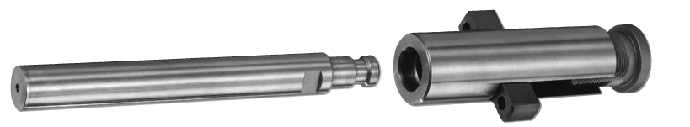

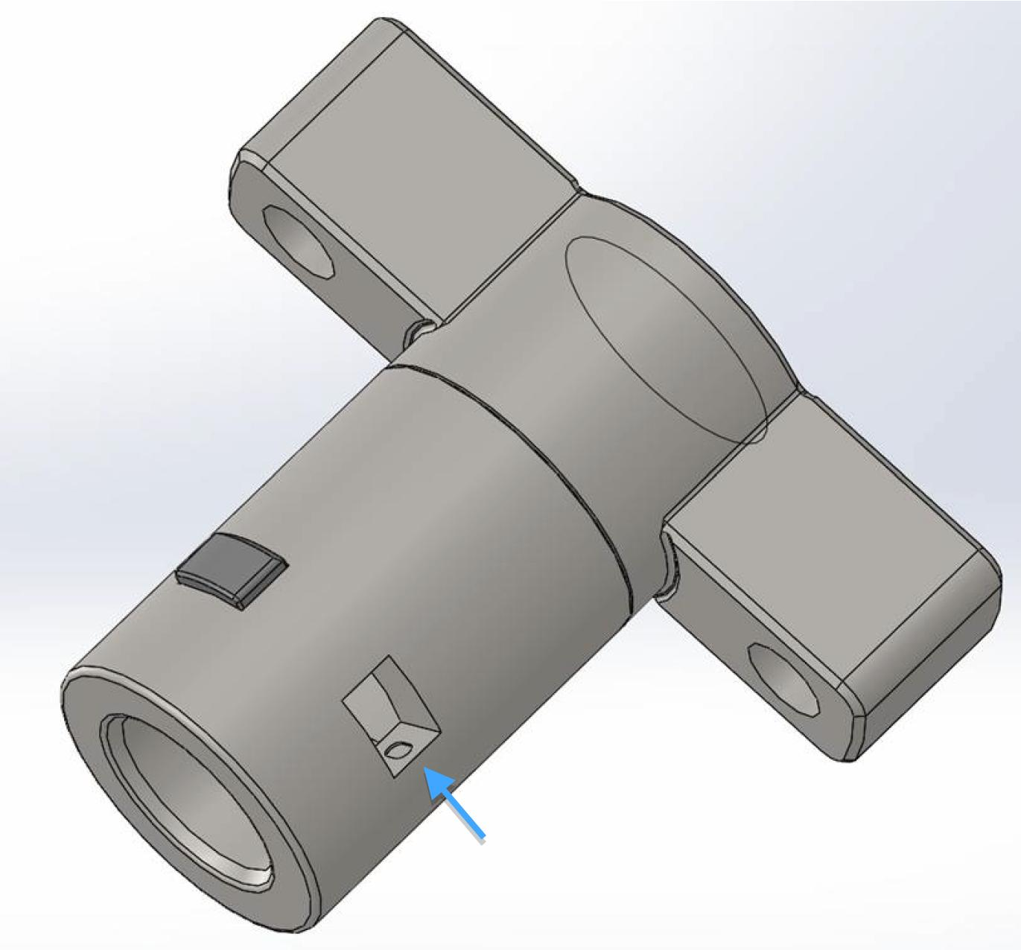

Cam Finger Body (shown above)

DME Internal Latch Lock – DKL

REMOVAL OF CAM FINGERS

Step 1
See NOTES below before proceeding.
Disassemble DKL so you have Cam Finger Body with Cam Fingers.
Firmly retain Cam Finger Body. (DO NOT USE VISE)
Align punch with Cam Finger in Cam Finger Body.
Punch is struck firmly and quickly with a hammer.

Step 2
The Cam Finger is knocked toward inside diameter region of Cam Finger Body.
(The Cam Finger pushes against the Locking Pin.)

Step 3
A portion of Locking Pin is cleanly sheared off and travels with the moving Cam Finger toward the inside diameter of the Cam Finger Body.

Step 4
Both the Cam Finger and broken piece of Locking Pin drop into the inside diameter of the Cam Finger Body. Remove existing Locking Pin and Rubber Spring. Proceed to next Cam Finger.

NOTES:
- Cold rolled, low carbon steel or brass must be used as a removal punch to avoid damaging the Cam Fingers and/or the Cam Finger Body.
- The contact surface of the punch (where it rests against the Cam Finger) should be profiled with a curved surface and be smaller than the Cam Finger surface.
- Ensure the Cam Finger Body is firmly retained before attempting Cam Finger removal.
DME Internal Latch Lock – DKL
CAM FINGER INSTALLATION

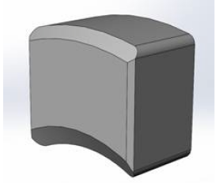

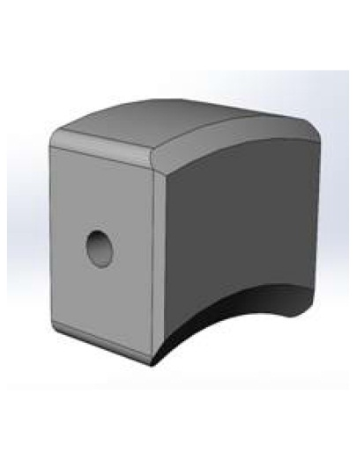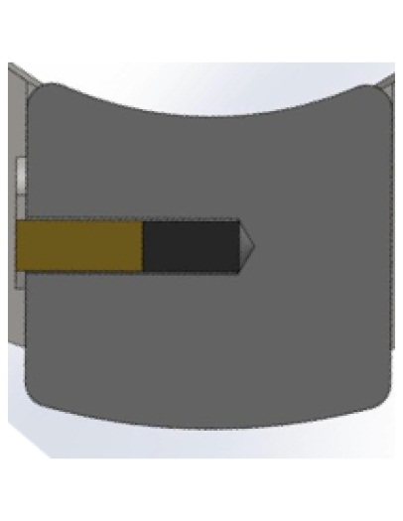
- Locate blind hole on side of Cam Finger.
- Insert Rubber Spring into blind hole on side of Cam Finger.
- Insert Locking Pin onto Rubber Spring, in blind hole, on side of Cam Finger.

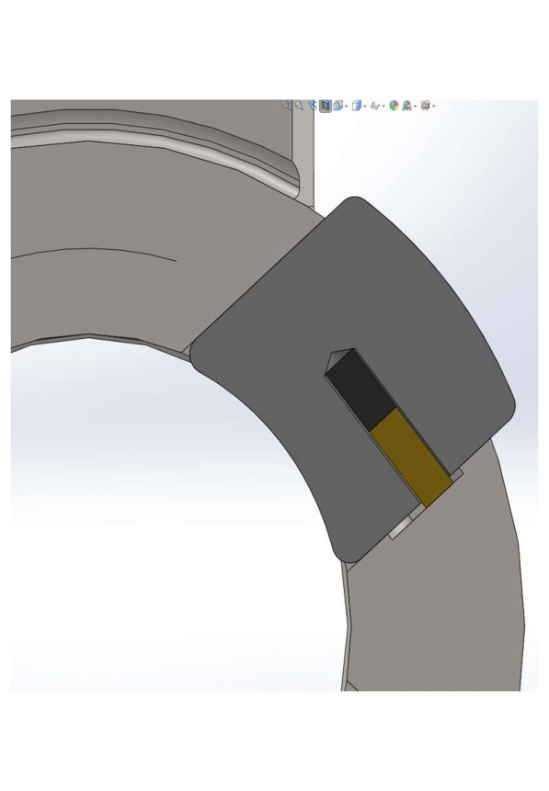
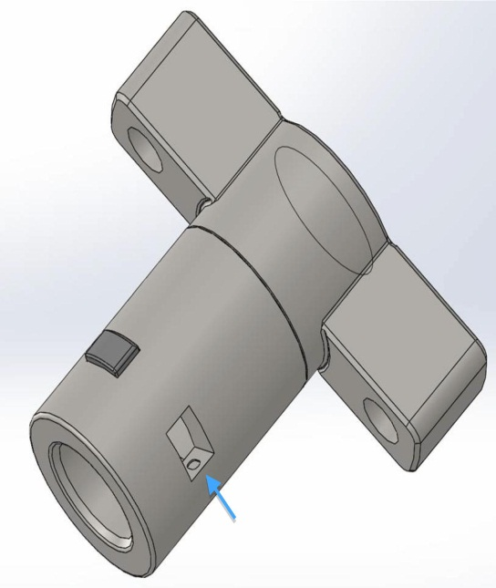
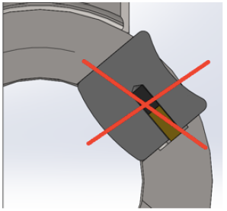
- On Cam Finger Body, locate milled slot (see blue arrow) on side of Cam Finger Body.

- Insert Cam Finger (with Rubber Spring & Locking Pin) into Cam Finger slot of Cam Finger Body, gently compressing Locking Pin into Rubber Spring while inserting so Locking Pin is flush with side of Cam Finger.

IMPORTANT: Ensure the radii on Cam Finger properly align with the radii of Cam Finger Body (see images)

- As Cam Finger is inserted into Cam Finger slot, the Locking Pin will snap into milled pocket on side of Cam Finger Body, which will then retain Cam Finger in Cam Finger Body. Repeat for each Cam Finger.

